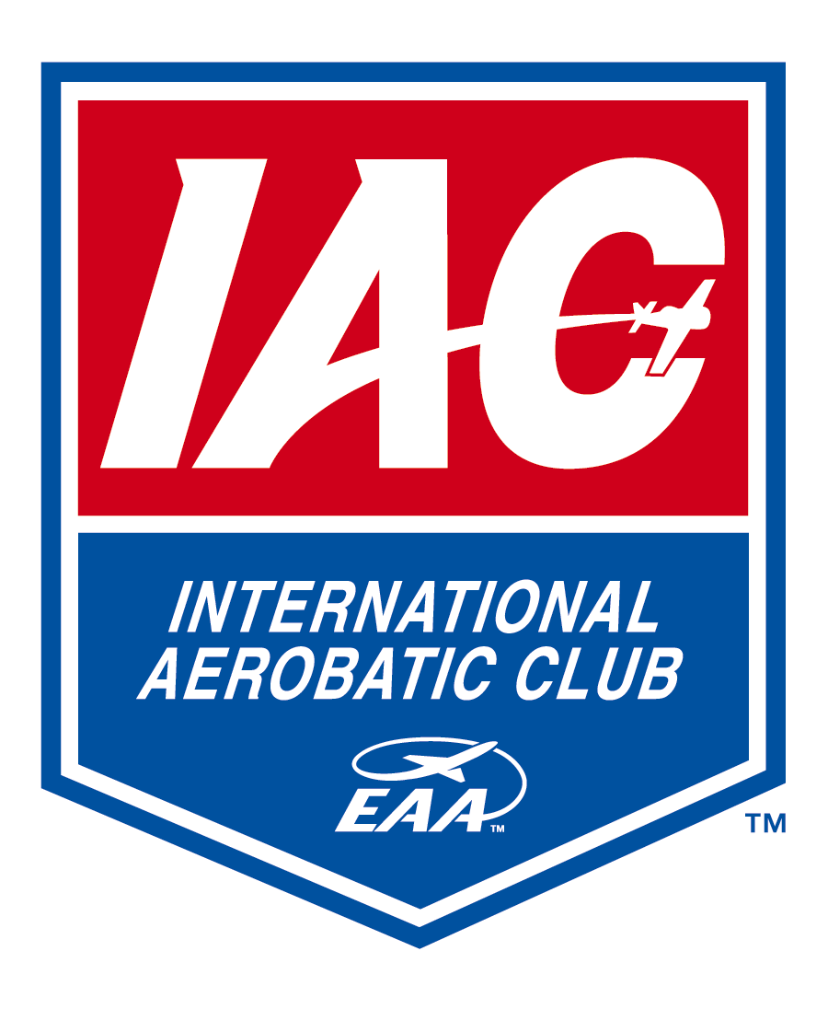
INTERNATIONAL AEROBATIC CLUB
Official Contest Entry Form

CONTEST: Name: Date:
Location: Type: Power Glider
Contest Category: Primary Sportsman Intermediate Advanced Unlimited

Patch Category: Primary Sportsman Intermediate Advanced Unlimited

First-Time Competitor: (mark if, first time flying in chosen contest category)

PILOT: Name: IAC Number:
Address:
Street City State/Zip
Country: U.S. Citizen: Yes No
E-mail Address: Birth Date:
Phone: Cell Phone:
IAC Chapter: FAI Sporting License:
License Type: License Number:
Emergency Contact:
Name Phone number(s)

OWNER: Name: Phone Number:
Address:
Street City State/Zip

AIRCRAFT: Make/Model: “N” Number:
Grass Roots Qualified Type of Airworthiness: Experimental Acrobatic
Engine Make/Model/Horsepower:

Insurance Information:
Company Type Amount

The undersigned owner and pilot hereby for entry in the aforementioned contest and, if permitted to participate in said contest, agree to the following terms and conditions:

- That all statements on this application are true;

- That the owner, pilot and aforementioned aircraft currently comply and will continue to comply throughout this contest with all applicable Federal Aviation Regulations and all IAC rules and regulations;

- That participation in this contest is not authorized until acceptance is evidenced below by the contest director and the entry fee has been paid;

- That all requirements of the various contest committees will be immediately complied with upon request, including technical inspections and attendance at all pilot briefings;

- That the undersigned assign and transfer any and all rights to photograph, tape, film, or in any way reproduce the participation of owner, pilot and/or aircraft in this contest to the IAC, its agents, successors, or assigns;

- That the undersigned, for themselves, their heirs, administrators, and executors, hereby accept full and complete responsibility for and agree to release, indemnify, and hold the IAC, contest officials and sponsors, airport owners and operators and any agents thereof harmless from any and all damages or liability whether caused by or incurred by the undersigned as a result of their negligence, acts or omissions during participation in this contest;

- That the contest director may at any time and for any reason terminate participation of the owner, pilot, or aircraft in this contest, and neither the director nor the IAC shall incur any liability or further duty to the undersigned as a result thereof.

- The International Aerobatic Club, Inc. as well as its chapters, officers, directors, employees, agents, contractors and servants (all hereinafter referred to as “IAC”), are involved in varying degrees with the presentation of this contest. The IAC, HOWEVER, HAS ABSOLUTELY NO CONTROL NOR RESPONSIBILITY FOR ANY FLIGHT OR FLIGHT RELATED ACTIVITY RESULTING FROM ANY INDIVIDUAL’S ATTENDANCE AT OR PARTICIPATION IN ANY PHASE OF SAID CONTEST. ALL FLIGHT OR FLIGHT RELATED ACTIVITY IS REGULATED BY THE RULES AND REGULATIONS OF THE FEDERAL AVIATION ADMINISTRATION and/or FIELD PERSONNEL, INCLUDING BUT IN NO WAY LIMITED TO APPROACH, LANDING, TAXIING, PARKING, TAKE-OFF, DEPARTURE, AND PARTICIPATION IN SAID CONTEST. ALL PILOTS OPERATE THEIR AIRCRAFT AS PILOT IN COMMAND, AT THEIR OWN RISK AND EACH SUCH PILOT AS A CONDITION AND IN CONSIDERATION OF HIS OR HER ENGAGING IN SAID FLIGHT OR FLIGHT RELATED ACTIVITY THIS CONTEST, FOR HIMSELF, HIS HEIRS AND ADMINISTRATORS, RELEASE AND AGREES TO INDEMNIFY AND HOLD THE IAC HARMLESS FROM ANY AND ALL EXPENSES, DAMAGES, CAUSE OF ACTION, LOSSES, AND LIABILITY WHATSOEVER, WHETHER TO SAID PILOT OR TO ANY PASSENGERS OR OTHER THIRD PARTIES.

- The permitting of participation by contestant (owner and/or pilot) in no way shall be an approval or certification of the structural or mechanical ability of any aircraft or the competency of any pilot to perform the maneuvers necessary to participate in said contest.

Pilot’s Signature Date

Owner’s Signature Date

ACCEPTED FOR PARTICIPATION:

Contest Director’s Signature Date

Tab 3- Form 01

